Critical Log

My initial concern for development of the site lay in the necessity of a mobile compatible website, with this aspect of the brief came challenges such as utilizing media queries and dynamic element sizing. These techniques proved fiddly and time consuming as I adopted a trial and error approach to correctly proportion key aspects of the site. Due to my worry in regards to the site being compatible with smaller devices, aspects like the header and footer seem disproportionately large on desktop monitors. (pictured below are examples of media queries removing images to better fit a smaller screen)

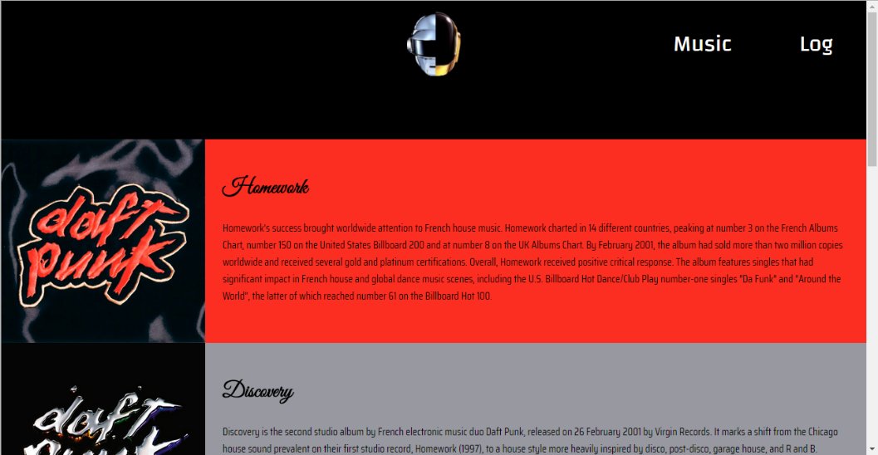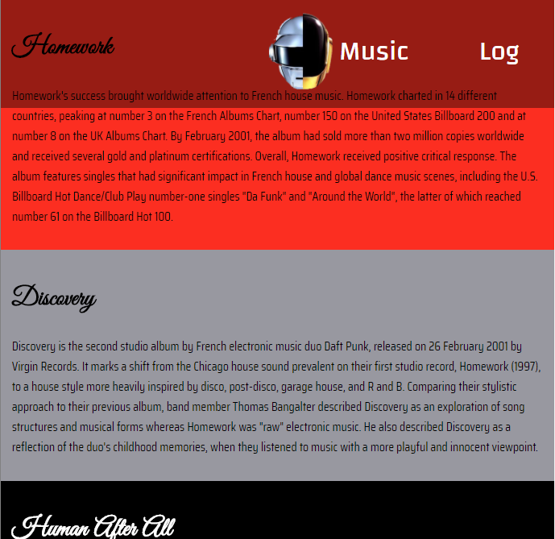

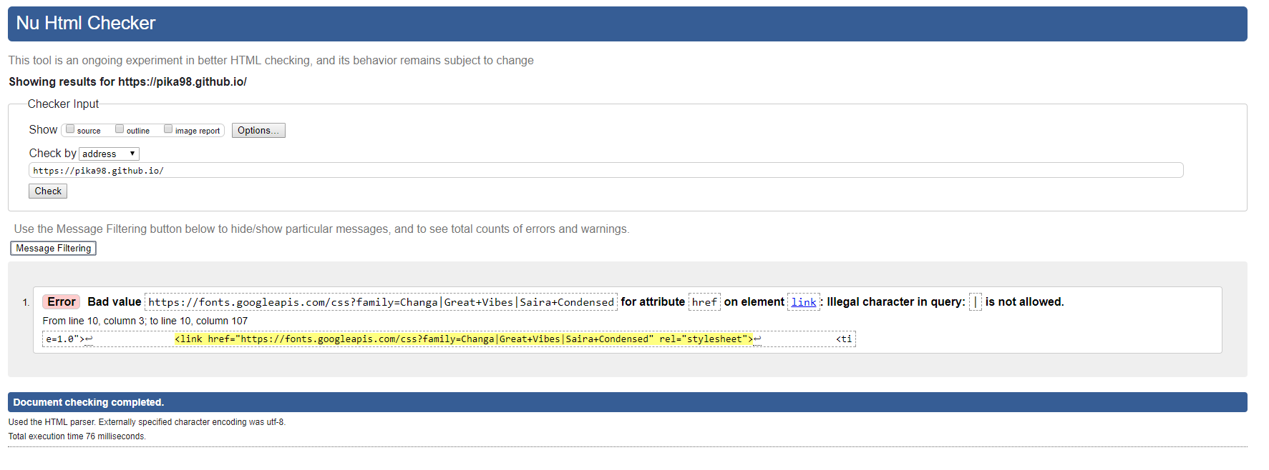Alongside this newfound importance of dynamic websites, recent years have also given way to a push in the idea of a standardised internet. Whilst HTML and CSS can be produced with a unique style depending on the author, standardisations such as w3c validity checks act to ensure that code published on the web will a standardised format. Other standards like the 508 law exist in order to encourage websites to be made for those with disabilities which may impede conventional website use. In the case of my website, I had planned to strictly abide to standards from the very start of the project, this resulted in minimal error correcting upon completion and was relatively simple given the capabilities of modern programming IDEs. (pictured below is the proof of w3c validity, one unavoidable error is displayed as a result of using google fonts)

Stemming from this sense of standardisation is the idea of interoperability with HTML. Due to the multitude of web browsers now available, a single website must be built to adapt to the browser it will be viewed on. This necessity reflects itself in code as the addition of vendor-prefixed properties, that are handled by a specific browser, ie; -moz-border-radius- would be handled by Firefox. I found this process difficult in my project. Unlike my approach to coding standardisation, I did not involve these prefixes as and when they were required. As a result, going back through my code to amend sections of CSS would be a huge reverse engineering process and as a result my website is only reliably stable on Chrome, IE9 and Edge.